**SQL QUERIES PERFORMED ON PIZZA SALES:**

1. **TOTAL REVENUE**:

SELECT SUM(total_price) AS total_revenue FROM pizza_sales;

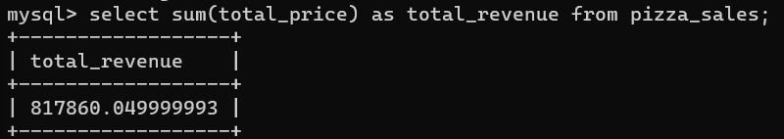

1. **TOTAL ORDERS**:

SELECT COUNT(DISTINCT order_id) AS total_orders FROM pizza_sales;

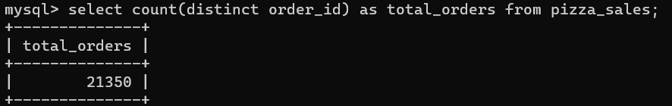

1. **AVERAGE ORDER REVENUE:**

SELECT (SUM(total_price) / COUNT(DISTINCT order_id)) AS avg_order_revenue FROM pizza_sales

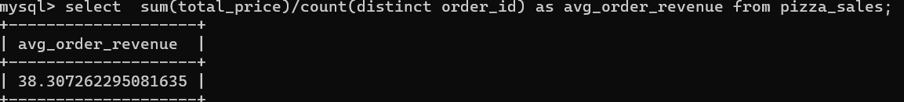

1. **PIZZAS SOLD:**

SELECT SUM(quantity) AS pizza_sold FROM pizza_sales

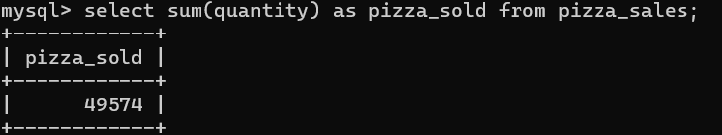

1. **AVERAGE PIZZAS SOLD PER ORDER:**

SELECT CAST(CAST(SUM(quantity) AS DECIMAL(10,2)) /

CAST(COUNT(DISTINCT order_id) AS DECIMAL(10,2)) AS DECIMAL(10,2))

AS avg_pizza_order

FROM pizza_sales



1. **TOTAL ORDERS PER DAY OF WEEK:**

SELECT DAYNAME(order_date) AS order_day,

COUNT(DISTINCT order_id) AS total_orders

FROM pizza_sales

GROUP BY DAYNAME((order_date);

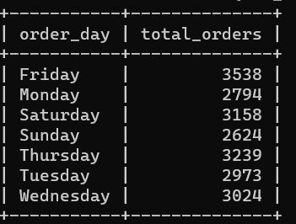

1. **TOTAL ORDERS PER MONTH:**

SELECT MONTHNAME(order_date) AS order_month,

COUNT(DISTINCT order_id) AS total_orders

FROM pizza_sales

GROUP BY MONTHNAME(order_date);

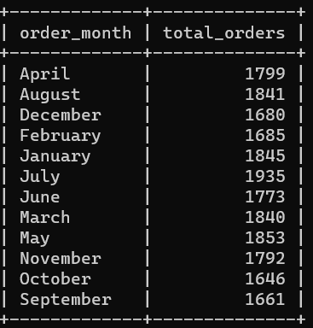

1. **SALES % FOR EACH PIZZA CATEGORY:**

SELECT pizza_category, CAST(SUM(total_price) AS DECIMAL(10,2)) as total_revenue, CAST(SUM(total_price) * 100 / (SELECT SUM(total_price) from pizza_sales) AS DECIMAL(10,2)) AS PCT

FROM pizza_sales

GROUP BY pizza_category;

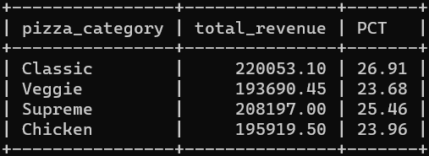

1. **SALES % FOR EACH PIZZA SIZE:**

SELECT pizza_size, CAST(SUM(total_price) AS DECIMAL(10,2)) AS total_revenue,

CAST(SUM(total_price) * 100 / (SELECT SUM(total_price) from pizza_sales) AS DECIMAL(10,2)) AS PST

FROM pizza_sales

GROUP BY pizza_size

ORDER BY pizza_size;

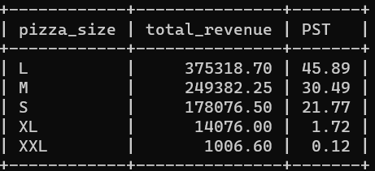

1. **TOTAL PIZZAS SOLD BY PIZZA CATEGORY:**

SELECT pizza_category, SUM(quantity) AS total_sold

FROM pizza_sales

GROUP BY pizza_category;

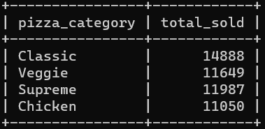

1. **TOP 5 PIZZAS BY REVENUE:**

SELECT pizza_name,SUM(total_price) as Revenue

FROM pizza_sales

GROUP BY pizza_name

ORDER BY Revenue DESC

LIMIT 5;

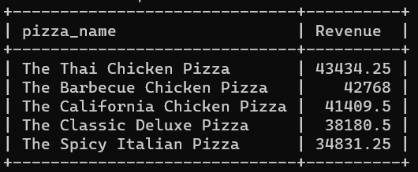

1. **TOP 5 PIZZAS BY QUANTITY:**

SELECT pizza_name,SUM(quantity) as total_sold

FROM pizza_sales

GROUP BY pizza_name

ORDER BY total_sold DESC

LIMIT 5;

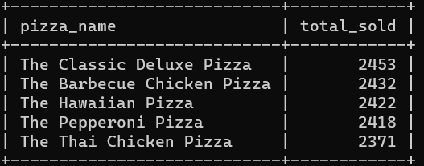

1. **TOP 5 PIZZAS BY TOTAL ORDER:**

SELECT pizza_name, COUNT(DISTINCT order_id) as total_order

FROM pizza_sales

GROUP BY pizza_name

ORDER BY total_order DESC

LIMIT 5;

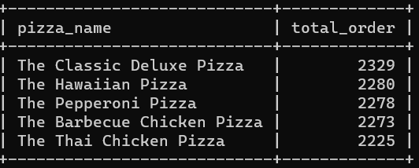

1. **BOTTOM 5 PIZZAS BY REVENUE:**

SELECT pizza_name, CAST(SUM(total_price) AS DECIMAL(10,2)) as Revenue

FROM pizza_sales

GROUP BY pizza_name

ORDER BY Revenue

LIMIT 5;

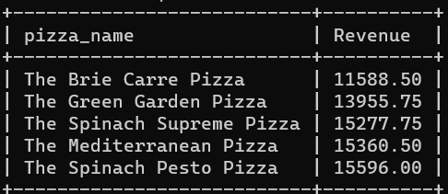

1. **BOTTOM 5 PIZZAS BY QUANTITY:**

SELECT pizza_name,SUM(quantity) as total_sold

FROM pizza_sales

GROUP BY pizza_name

ORDER BY total_sold

LIMIT 5;

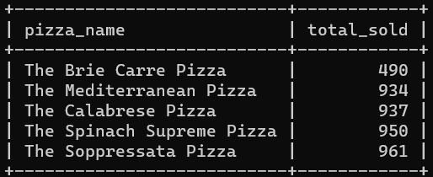

1. **BOTTOM 5 PIZZAS BY TOTAL ORDER**:

SELECT pizza_name, COUNT(DISTINCT order_id) as total_order

FROM pizza_sales

GROUP BY pizza_name

ORDER BY total_order

LIMIT 5;

